**CS Arrays Unit Lab: Card Array**

*Learning Target: I will write a program that uses multiple arrays, each with their own index variable.*

Make a file, CardArray.java, that creates an array of 52 elements containing Strings such as “Ace of Hearts”, “Two of Clubs”, and “Jack of Spades.”

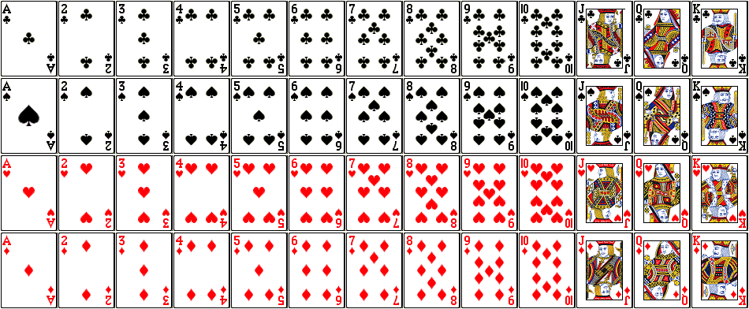**You should not type in all 52 elements,** but instead use a for loop to initialize the array.

1. Make two String arrays and hard code them with the choices
   1. ranks[] (Ace ……. King): 13 choices total (see the diagram above)
   2. suits[] (Diamonds, Hearts, Spades, Clubs) : 4 choices total
2. Make a third array cardNames[] that can hold 52 Strings.
3. Use a for loop to pick elements from ranks[] and suits[] to concatenate in cardNames[]
4. Print out your cardNames[] array to make sure you have one of each of the 52 cards

Bonus points:

* Randomly pick a poker hand (5 cards). (Hint: Use a parallel boolean array)
* Play “war” **one time** (randomly pick 2 cards and see which one is bigger).

**Rubric**

* Program is named CardArray.java
* Proper comment header
* Proper indentation
* Program has a String array of ranks, 13 elements big
* Program has a String array of suits, 4 elements big
* Program has a String array of cardNames, 52 elements big
* Program uses loops to pick elements from ranks and suits
* Program uses concatenation to put elements together
* When printed, cardNames array has no duplicates
* When printed, cardNames array has no missing or null elements
* **Example of an output:**



  






